EX.NO: 8 | Develop a TD learning agent
DATE:

AIM
To implement and visualize a SARSA (State–Action–Reward–State–Action) Temporal Difference learning algorithm for training an agent to find an optimal path in a Gridworld environment using reinforcement learning.
ALGORITHM
- Initialize the Gridworld environment and SARSA agent with learning parameters and an empty Q-table.
- For each episode, reset the environment and select an action using the ε-greedy policy.
- Execute the selected action, observe the reward and next state from the environment.
- Choose the next action and update the Q-table using the SARSA update rule.
- Repeat the process until a terminal (goal) state is reached for all episodes.
- Test the trained agent and visualize the optimal path using value and policy extraction.
PROGRAM:
import numpy as np
import matplotlib.pyplot as plt
import matplotlib.animation as animation
from IPython.display import HTML, display
import random
GRID_SIZE = 4
EPISODES = 500
ALPHA = 0.1
GAMMA = 0.9
EPSILON = 0.2
STEP_REWARD = -1.0
class GridworldEnv:
def __init__(self, size=GRID_SIZE):
self.size = size
self.nS = size * size
self.nA = 4
self.start_states = list(range(1, self.nS - 1))

def reset(self):
self.state = random.choice(self.start_states)
return self.state
def step(self, action):
row, col = divmod(self.state, self.size)
if action == 0:
row = max(row - 1, 0)
elif action == 1:
col = min(col + 1, self.size - 1)
elif action == 2:
row = min(row + 1, self.size - 1)
elif action == 3:
col = max(col - 1, 0)
self.state = (row * self.size) + col
done = (self.state == 0 or self.state == self.nS - 1)
reward = 0.0 if done else STEP_REWARD
return self.state, reward, done
class SarsaAgent:
def __init__(self, nS, nA, alpha, gamma, epsilon):
self.nA = nA
self.alpha = alpha
self.gamma = gamma
self.epsilon = epsilon
self.q_table = np.zeros((nS, nA))
def choose_action(self, state):
if random.uniform(0, 1) < self.epsilon:
return random.randint(0, self.nA - 1)
else:
max_q = np.max(self.q_table[state])
best_actions = np.where(self.q_table[state] == max_q)[0]
return random.choice(best_actions)
def learn(self, state, action, reward, next_state, next_action):
current_prediction = self.q_table[state, action]
next_prediction = self.q_table[next_state, next_action]
td_target = reward + (self.gamma * next_prediction)
td_error = td_target - current_prediction
self.q_table[state, action] = current_prediction + (self.alpha * td_error)
def extract_v_and_policy(q_table, nS, nA):
V = np.max(q_table, axis=1)
policy = np.zeros((nS, nA))
for s in range(nS):
best_a = np.argmax(q_table[s])
policy[s][best_a] = 1.0
return V, policy
def animate_test_run(test_path, V, policy, size):
fig, ax = plt.subplots(figsize=(6, 6))
arrows = {0: '↑', 1: '→', 2: '↓', 3: '←'}
start_state = size * (size - 1)
def update(frame):
ax.clear()
ax.matshow(V.reshape(size, size), cmap='Blues')
agent_state = test_path[frame]
for s in range(len(V)):
row, col = divmod(s, size)
if s != 0 and s != len(V) - 1:
best_act = np.argmax(policy[s])
if s == start_state:
ax.text(col, row - 0.3, "START", va='center', ha='center',
color='purple', fontsize=10, weight='bold')
else:
ax.text(col, row - 0.2, f"{V[s]:.1f}",
va='center', ha='center', color='black')
ax.text(col, row + 0.2, arrows[best_act],
va='center', ha='center', color='red',
fontsize=16, weight='bold')
else:
label = "GOAL 1" if s == 0 else "GOAL 2"
ax.text(col, row, f"{label}\n🏁",
va='center', ha='center',
color='green', fontsize=11, weight='bold')
if s == agent_state:
circle = plt.Circle((col, row), 0.3, color='red', alpha=0.5)
ax.add_patch(circle)
ax.text(col, row, "🤖", va='center', ha='center', fontsize=20)
ax.set_xticks([])
ax.set_yticks([])
ax.set_title(f"Trained Agent Path: Step {frame + 1}/{len(test_path)}", pad=20)
anim = animation.FuncAnimation(
fig, update, frames=len(test_path), interval=500, repeat=False
)
plt.close(fig)
display(HTML(anim.to_jshtml()))

if __name__ == "__main__":
env = GridworldEnv(size=GRID_SIZE)
agent = SarsaAgent(env.nS, env.nA, ALPHA, GAMMA, EPSILON)

for episode in range(1, EPISODES + 1):
state = env.reset()
action = agent.choose_action(state)
done = False
while not done:
next_state, reward, done = env.step(action)
next_action = agent.choose_action(next_state)
agent.learn(state, action, reward, next_state, next_action)
state = next_state
action = next_action
start_state = env.size * (env.size - 1)
env.state = start_state
state = start_state
agent.epsilon = 0.0

test_path = [state]
done = False
max_steps = env.nS * 2
steps = 0

while not done and steps < max_steps:
action = agent.choose_action(state)
next_state, reward, done = env.step(action)
test_path.append(next_state)
state = next_state
steps += 1
V, policy = extract_v_and_policy(agent.q_table, env.nS, env.nA)
animate_test_run(test_path, V, policy, GRID_SIZE)

Output:
🧠 Training TD Agent (SARSA) for 500 episodes...
✅ Completed Episode 100
✅ Completed Episode 200
✅ Completed Episode 300
✅ Completed Episode 400
✅ Completed Episode 500
🎉 Training complete! Running a test episode...
🎬 Rendering animation of the agent walking to the goal...
/tmp/ipython-input-3854654225.py:150: UserWarning: Glyph 127937 (\N{CHEQUERED FLAG}) missing from font(s) DejaVu Sans.
display(HTML(anim.to_jshtml()))
/tmp/ipython-input-3854654225.py:150: UserWarning: Glyph 129302 (\N{ROBOT FACE}) missing from font(s) DejaVu Sans.
display(HTML(anim.to_jshtml()))

OUTPUT

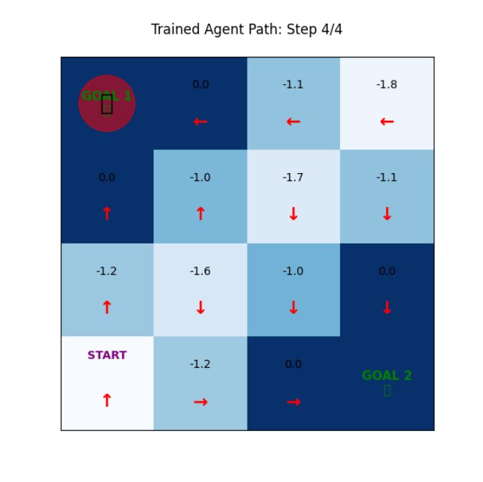
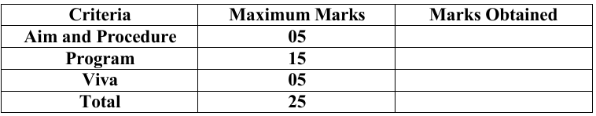

RESULT:
The SARSA-based reinforcement learning agent was successfully implemented and trained in a Gridworld environment. The agent learned an optimal policy through repeated episodes and was able to navigate from the start state to one of the goal states efficiently. The learned value function and policy were visualized, and the agent’s optimal path was animated, demonstrating effective learning using Temporal Difference methods.

EX.NO: 9 | Implement Monte Carlo Tree Search for game playing.
DATE:

AIM
To implement the Monte Carlo Tree Search (MCTS) algorithm for playing the Tic-Tac-Toe game, enabling an AI agent to select optimal moves through simulation, exploration, and exploitation.

ALGORITHM
- Initialize the Tic-Tac-Toe game state and create the root node for MCTS.
- Repeat for a fixed number of iterations: select the child node with the highest UCB1 value.
- Expand the tree by adding a new child node for an untried legal move.
- Simulate a random game from the expanded node until a terminal state is reached.
- Backpropagate the simulation result by updating win and visit counts of all visited nodes.
- Choose the move corresponding to the child node with the highest visit count as the best move.
PROGRAM:
import math
import random
MCTS_ITERATIONS = 1000
C_PARAM = 1.41
class TicTacToe:
def __init__(self, state=None, player_to_move=1):
self.state = state if state else [0] * 9
self.player_to_move = player_to_move
def get_legal_moves(self):
if self.get_winner() != 0:
return []
return [i for i, val in enumerate(self.state) if val == 0]
def play_move(self, move):
new_state = list(self.state)
new_state[move] = self.player_to_move
return TicTacToe(new_state, -self.player_to_move)

def get_winner(self):
win_conditions = [
[0, 1, 2], [3, 4, 5], [6, 7, 8],
[0, 3, 6], [1, 4, 7], [2, 5, 8],
[0, 4, 8], [2, 4, 6]
]
for combo in win_conditions:
s = sum(self.state[i] for i in combo)
if s == 3:
return 1
if s == -3:
return -1
return 0
def is_terminal(self):
return self.get_winner() != 0 or 0 not in self.state
def display(self):
symbols = {1: 'X', -1: 'O', 0: ' '}
print("-" * 13)
for row in range(3):
r = [symbols[self.state[row * 3 + col]] for col in range(3)]
print(f"| {r[0]} | {r[1]} | {r[2]} |")
print("-" * 13)
class MCTSNode:
def __init__(self, game_state, parent=None, move=None):
self.game_state = game_state
self.parent = parent
self.move = move
self.untried_moves = game_state.get_legal_moves()
self.children = []
self.visits = 0
self.wins = 0.0
def ucb1(self):
if self.visits == 0:
return float('inf')
exploitation = self.wins / self.visits
exploration = C_PARAM * math.sqrt(math.log(self.parent.visits) / self.visits)
return exploitation + exploration
def mcts_search(root_state, iterations=MCTS_ITERATIONS):
root_node = MCTSNode(root_state)
for _ in range(iterations):
node = root_node
state = root_state
while node.untried_moves == [] and node.children != []:
node = max(node.children, key=lambda c: c.ucb1())
state = state.play_move(node.move)
if node.untried_moves != []:
move = random.choice(node.untried_moves)
node.untried_moves.remove(move)
state = state.play_move(move)
child_node = MCTSNode(state, parent=node, move=move)
node.children.append(child_node)
node = child_node
rollout_state = state
while not rollout_state.is_terminal():
random_move = random.choice(rollout_state.get_legal_moves())
rollout_state = rollout_state.play_move(random_move)
winner = rollout_state.get_winner()
while node is not None:
node.visits += 1
player_who_just_moved = -node.game_state.player_to_move
if winner == player_who_just_moved:
node.wins += 1.0
elif winner == 0:
node.wins += 0.5
node = node.parent
best_child = max(root_node.children, key=lambda c: c.visits)
return best_child.move
if __name__ == "__main__":
game = TicTacToe()
print("🤖 MCTS AI (X) vs 🎲 Random Agent (O)")
game.display()
while not game.is_terminal():
if game.player_to_move == 1:
move = mcts_search(game)
else:
move = random.choice(game.get_legal_moves())
game = game.play_move(move)
game.display()
winner = game.get_winner()
print("\n🏁 GAME OVER 🏁")
if winner == 1:
print("🏆 MCTS AI (X) WINS!")
elif winner == -1:
print("🎉 Random Agent (O) WINS!")
else:
print("🤝 It's a DRAW!")

OUTPUT:
🤖 MCTS AI (X) vs 🎲 Random Agent (O)
-------------
| | | |
-------------
| | | |
-------------
| | | |
-------------

🧠 MCTS AI is thinking... (Running 1000 simulations)
🤖 AI chooses position 4
-------------
| | | |
-------------
| | X | |
-------------
| | | |
-------------

🎲 Random Agent's Turn...
🎲 Random Agent chooses position 0
-------------
| O | | |
-------------
| | X | |
-------------
| | | |
-------------

🧠 MCTS AI is thinking... (Running 1000 simulations)
🤖 AI chooses position 1
-------------
| O | X | |
-------------
| | X | |
-------------
| | | |
-------------

🎲 Random Agent's Turn...
🎲 Random Agent chooses position 2
-------------
| O | X | O |
-------------
| | X | |
-------------
| | | |
-------------

🧠 MCTS AI is thinking... (Running 1000 simulations)
🤖 AI chooses position 7
-------------
| O | X | O |
-------------
| | X | |
-------------
| | X | |
-------------
🏁 GAME OVER 🏁
🏆 MCTS AI (X) WINS!



Result:
The Monte Carlo Tree Search (MCTS) algorithm was successfully implemented for the Tic-Tac-Toe game. The AI agent effectively selected optimal moves by performing multiple simulations using selection, expansion, simulation, and backpropagation phases. The MCTS-based AI consistently outperformed the random agent, either winning the game or resulting in a draw, thereby demonstrating the effectiveness of MCTS in decision-making problems.

